Project Name : LendMoney

Team Name: LendMoney Solutions

LendMoney Design Document

System Architecture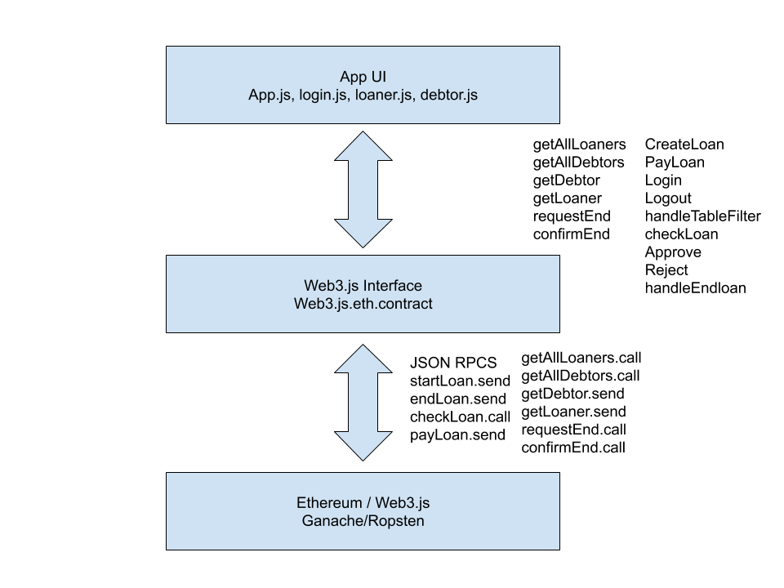

Smart Contract Design

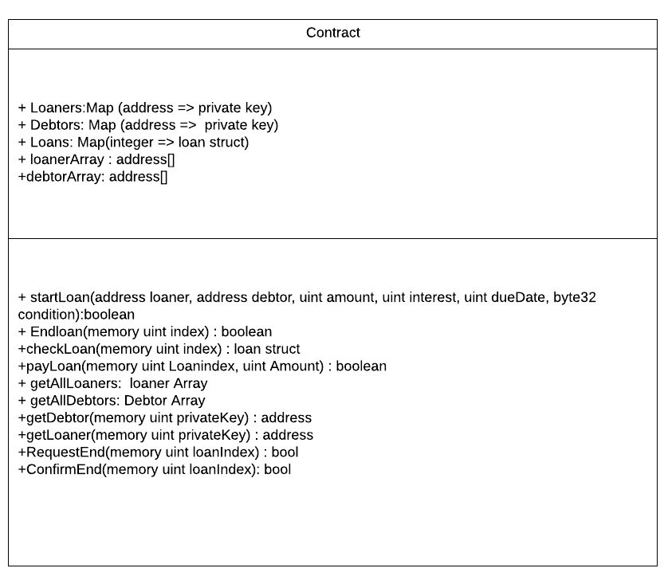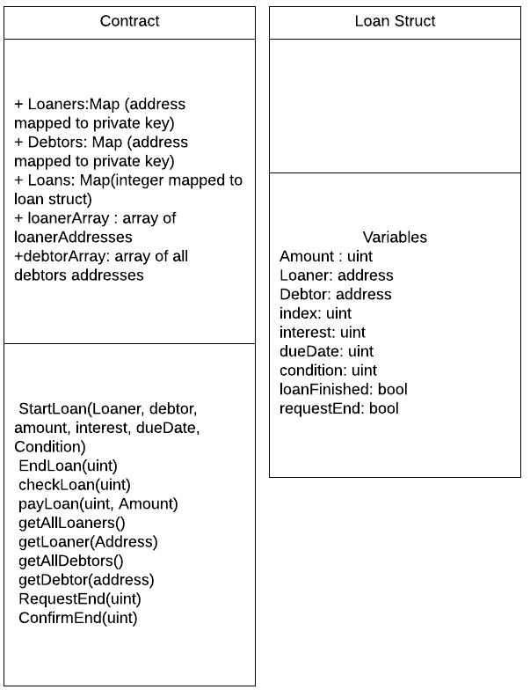

Variables:

Loaners: A map containing all loaner addresses, the key is the user private key

Debtors: A map containing all debtor addresses, the key is the user private key

Loans: A map containing all loan structs, the key is a uint

loanerArray: An array containing all loaner Addresses

debtorArray: An array containing all debtor Addresses

Methods:

StartLoan : The constructor for a new loan struct

endLoan: The loaner can call this function to end the loan

checkLoan: A view function that shows the properties of the specified loan struct

payLoan: pays the specified amount to the specified loan

getAllLoaners: Shows the LoanerArray contents on the frontend

getAllDebtors: Shows the DebtorArray contents on the frontend

getLoaner: gets the address of a loaner identified by their private key

getDebtor: gets the address of a debtor identified by their private key

RequestEnd: called by the debtor, sets the ‘requestEnd’ bool to true

ConfirmEnd: called by the loaner, ends the loan if ‘requestEnd’ bool is true

UI Mockup

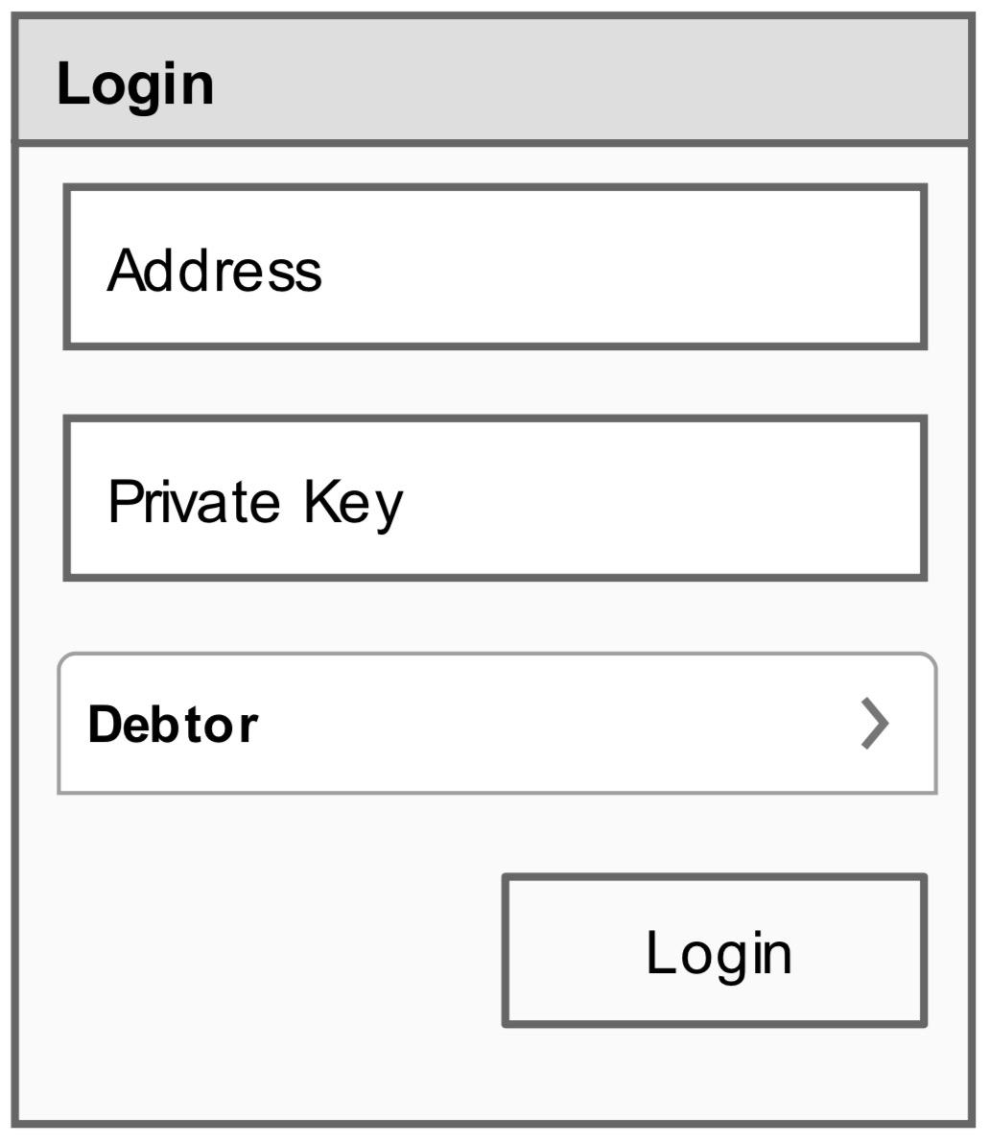

Debtor Login Page

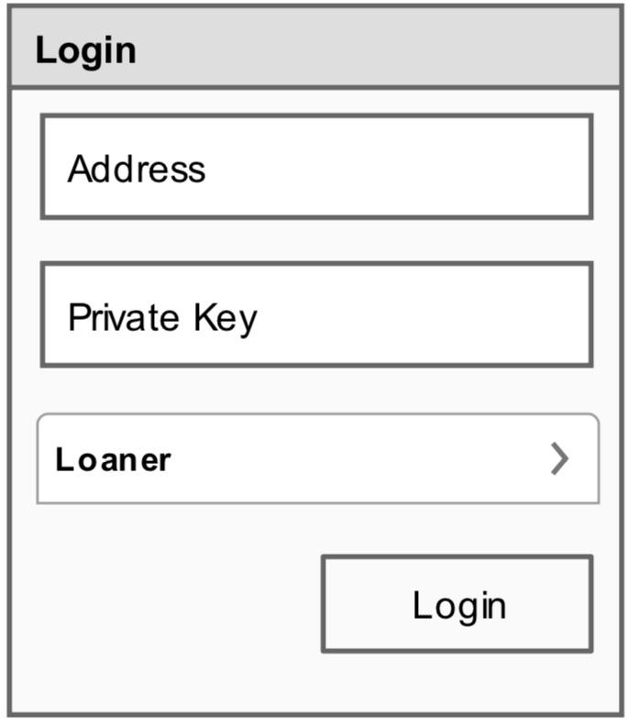

Loaner Login Page

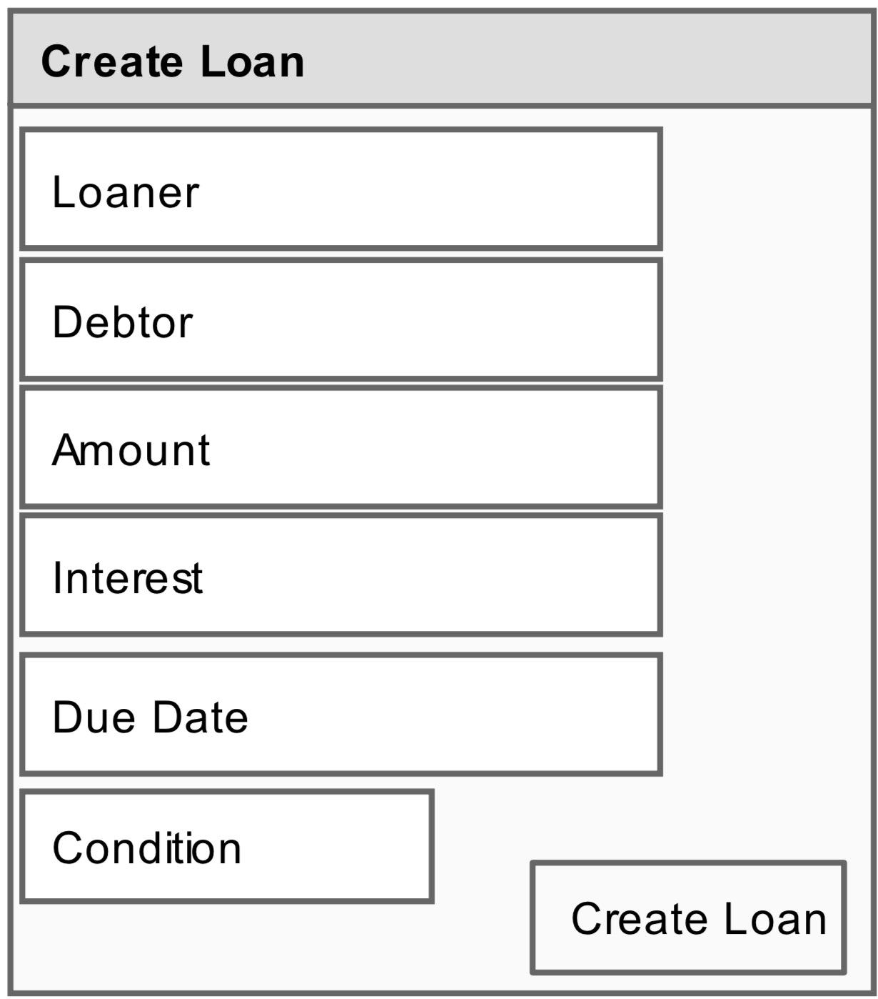

Create Loan Page

Debtor Homepage 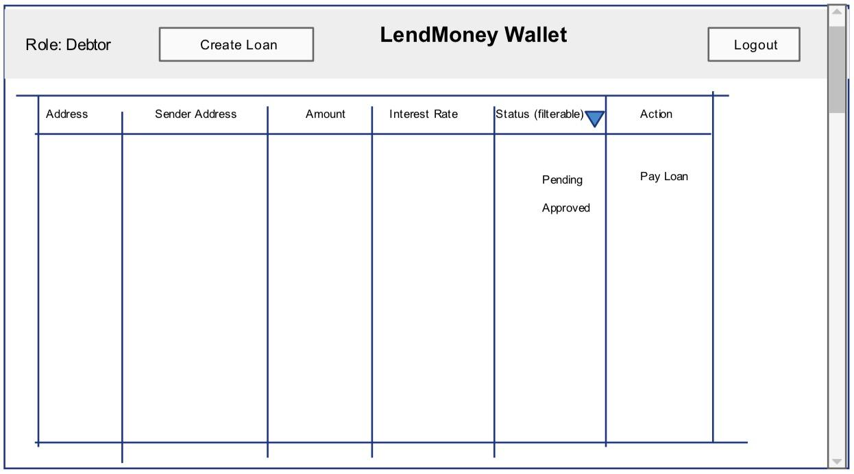

Loaner Homepage

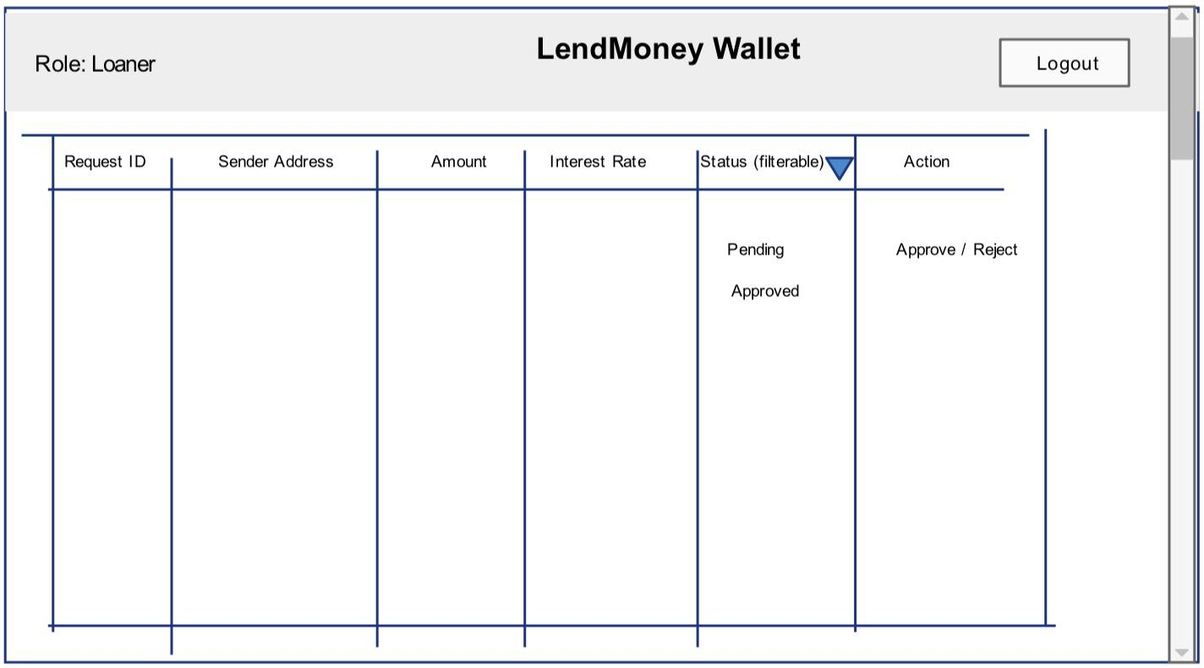

Workflows

Start a Loan

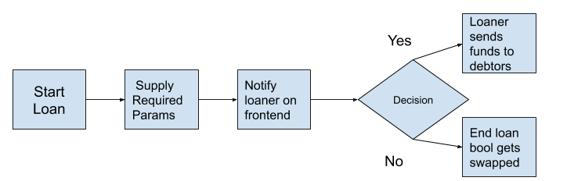

Debtor Calls RequestEnd

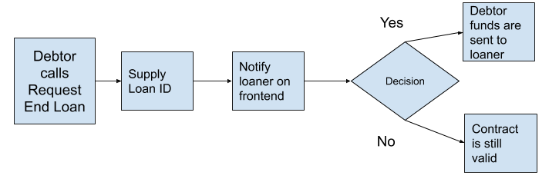

Loaner Confirms RequestEnd

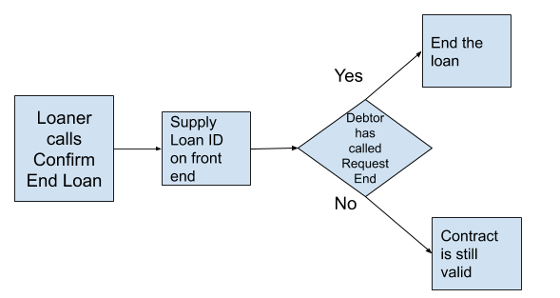

Loaner Calls endLoan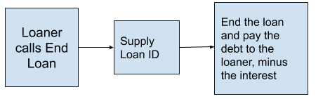

Check Loan is called

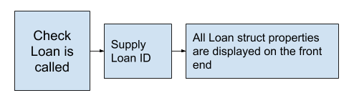

Debtor Pays a loan

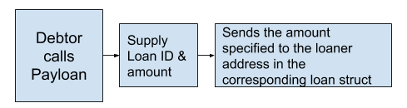

Get Debtor/Loaner by private key

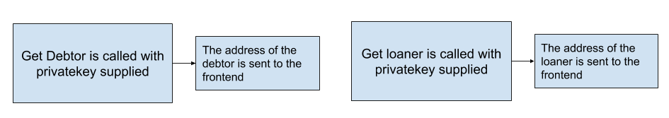

Get All Loaners/Debtors

